

RENGANAYAGI VARATHARAJ
COLLEGE OF ENGINEERING
Salvarpatti,Sivakasi –626128
FACULTY PROFILE

Faculty Name | R.BALAJI
Designation | ASSISTANT PROFESSOR
Qualification | B.E., M.Tech.,
Area of Specialization | VLSI DEGIGN
AICTE ID | 1-

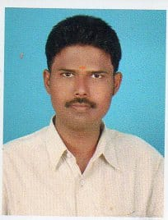
Experience: Research Publications:

Teaching | 8 Years 6Months |  | Journals (SCI, Scopus & UGC) | 01
Industry | 1 Year 8Months |  | Conferences | National Level : 2  International Level:1
Research | Nil |  | Patent | Nil

Programs Participated: Research & Professional Membership Details:

FDP / FEP | FDP: 03 |  | Google Scholar ID
Workshop | 05 |  | Professional Membership
Seminar | 05 |  | Books Publication
Conference | 02 |  | Awards (any)
Symposium | 3 |  | Awards (any)

Personal Details: Additional Responsibilities:

Date of Birth | 14/06/1988 |  | Institution | - Placement Coordinator
Email ID | balajir@rvce.ac.in |  | Department
Contact | +91 6381617729 |  | Department

Subjects Taught:
 | Sub. Code | Title
UG Level | EC3552 | VLSI and Chip Design
UG Level | CS3691 | Embedded Systems and IOT
UG Level | EE3402 | Linear Integrated Circuits
UG Level | EE8591 | Digital Signal Processing
UG Level | EC8691 | Microprocessor and Microcontroller

Any other information (if any):
- Nil | - Nil

